INSTRUCTIONS
ONLINE VENDOR REGISTRATION

On our corporate website www.hindustanpetroleum.com a link is provided for ‘Vendor registration’. The portal has been revamped to facilitate vendors for updation of latest information like Change in company profile, Increase/decrease of Financial status, Addition/deletion of Item class etc.
The process for updation of details and for new registration is illustrated below:
Home page revised in “Vendor Registration” link as below:
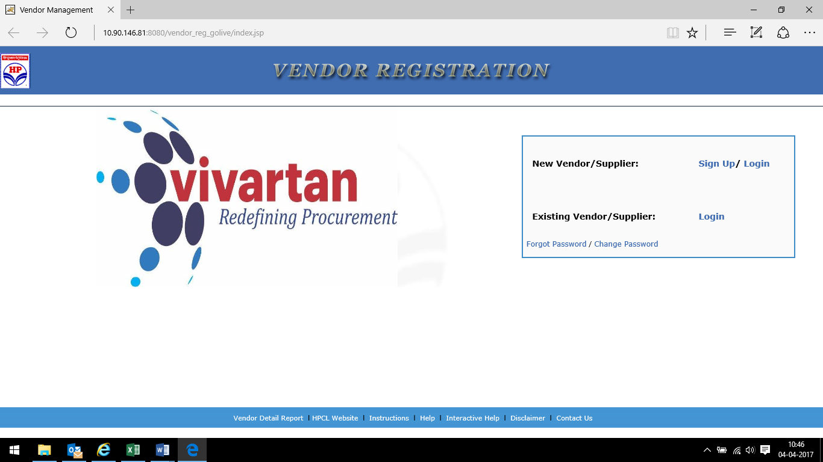

There are two options A) New Vendor and B) Existing vendor.
A. New Vendor/Supplier : is for fresh registration with HPCL. It has two options. 1. Sign up & 2. Log in.
1.Sign up is for fresh registration.
2. “ Log in” option is available for those vendors who have not completed online application. Here vendor can complete the application be entering Application number starting as HP000….. and Password.

B. Existing Vendor/Supplier. This option is available for existing vendors enlisted with HPCL for updation of profile.
Existing vendors can enter the link by entering application no. “HP000..” and password or his 8-digit vendor code with HPCL (e.g. 28000012, 27100000 etc) with BTS password for updation of details.
Following is the screen shot:

HPCL WELCOMES
(Vendor Name)

Please select appropriate options
FOR RE-REGISTRATION(KYV)
Re-registration (KYV)
PROFILE UPDATES
Name & Address SSI/MSME details Registered Items and Financial Limits
---------------------------------------------------------------------------------------------------
Existing vendor/supplier” vendor will get two options :
- FOR RE-REGISTRATION(KYV)
- PROFILE UPDATES

Re-registration option is available for those vendors who are enlisted with HPCL long back as such current details of vendor need to be updated e.g. change in company profile, Financial turnover, Highest work order executed, addition of items etc.
On clicking “ Profile update”, three options are available viz. a) Name and address b)SSI/ MSME details c) Registered Items and Financial Limits Vendor can choose any of the above options or all the options as per his requirement.
----------------------------------------------------------------------------------------------------
Process for New Registration:
Now click on ‘New Registration’ link and the registration for following two types can be done.

A. Permanent registration
B. Temporary registration for participating in Public tenders

A. Basic procedure for permanent registration:

- After clicking on the link “New Register”, one-page form will appear. Tick on Permanent Registration. Fill in the Form giving your email id, PAN number and other details. Enter your own password while registering and remember this password for future logins.

- A unique No. [eg. HP00000123] will be allotted and the same along with a confirmation link will be sent to your email id.

- Open the website using the confirmation link and login using the unique No. which has been e-mailed to you and your password.

- A detailed Online Registration Form will then appear with the Index on the left side.

- The application need to be filled online. The scanned copy of signed and stamped supporting documents need to be uploaded online from the attachment page. The SAVE button can be used to save the work during the filling up of application form.

- Once all the related fields are filled and necessary documents are uploaded, the final submission of the application to be done online by clicking Final submission button.

- Registration Fee: It has two options: Online payment or by way of DD.

  - A Demand Draft of Rs.5000/- plus applicable GSTN @ 18% from a Scheduled Bank [other than Co-operative Banks] payable to “M/s Hindustan Petroleum Corporation Ltd.”, towards the Registration Fee to be sent to the ‘Primary Location’ chosen by you. A Covering note to be enclosed along with the DD with details such as Name, address, contacts, Application number of the Vendor. Application Fee is non-refundable. Online payment option is also available for the vendor.

  - In case of Re-registration the Registration fee is not required. However vendor need to provide the reference of the original registration certificate along with the copy of the same in case registered previously.

- The application will then be scrutinized by the Registration Committee and if eligible, you will be sent a communication letter indicating your registration status

- Incomplete applications will be rejected.

- Forms not completed/not given “Final Confirmation” within 180 days, of the date of first login into the Online Registration Form, will be deactivated; and the entire process will have to be started again. “

- One Application will be accepted per firm/company for registration. The Vender can mention the HPCL business units/Functions for registration as a combination of Primary and Secondary Location while filling the application form.

*****************************************************************

B. Basic procedure for temporary registration for participating in Public Tenders:

1. When you click on the link “New Users Click here for temporary registration” on the E-procurement website, you will be directed to the Vendor Registration Portal. Or Alternately, please log into http://www.hindustanpetroleum.com/ and Go to link Vendor Registration. Click on “ Sign up ”, read the instructions and click on “ Click to Proceed”. A one-page form will appear.

2. Tick on temporary registration and Fill in the Form giving your email id, PAN number and other details. Enter your own password while registering and remember this password for future logins.

3. A unique No. [eg. HP00000123] will be allotted and the same along with a confirmation link will be sent to your email id.

4. Click on the Confirmation Link provided in your email to activate the password.

5. To quote for the Public tender, please go to the site https://etender.hpcl.co.in.

6. Click on Temporarily registered User and log into the site by giving your email id and password which has been activated.

Links like HELP menu is also available wherein screen shots are provided for each and every stage of filling the registration form and Interactive help is also provided wherein interactive guidance is provided while filling up the form.
Click on “Contact us” to get contact details of helpdesk or location based vendor management officer.

